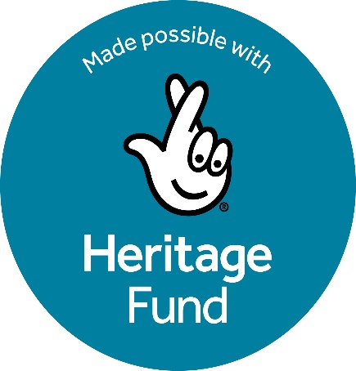
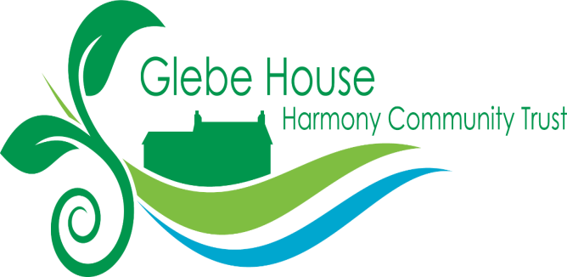

Invitation to tender

Role: Facilitator/Planner for the Green Community Hub for People, Plants and Pollinators

Organisation: Harmony Community Trust (HCT)

Project title: The Green Community Hub for People, Plants and Pollinators

Role: Facilitator/Planner

Location: Harmony Community Trust’s Glebe House estate, 23 Bishopscourt Road, Kilclief, BT30 7NZ

Duration of Assignment: 12 months (months 4-15 of a 15-month project)

Funder: The National Lottery Heritage Fund

Reporting to: Green Community Hub Task Group (A subgroup of four trustees who have responsibility for oversight of the project)

Budget; £6,000 to include VAT, travel and expenses

Closing date for tenders is 5pm Sunday 7th December. Interviews will then be arranged.

Offers are invited for the freelance position of Facilitator/Planner. Potential candidates should provide a description of how they would approach the project, including evidence that they meet the personal specifications below, and an overall price, which should include all costs for personal time and VAT. Materials for use in presentations and plan production will be provided by HCT.

Background Information

This project has been made possible through funding provided by the National Lottery Heritage Fund.

In this project HCT aims to engage local communities and volunteers in transforming its 8.5-acre Glebe House estate into a sustainable Green Community Hub. Through this initiative we will conserve the site’s fragile and ecologically rich environment, uncover and share its historical and cultural heritage, and build a long-term community-led model of stewardship and environmental education which harnesses our rich social and environmental heritage.

The project will undertake a preliminary ecological appraisal and will also engage and consult schools, volunteers, residents and other organisations to help articulate our future management plans. We will develop a Land Use Plan, a ten-year Conservation Management Plan and a three-year Action Plan. This will lay the foundations for future, larger-scale activities aligned with the Heritage Fund’s priorities of heritage conservation, community engagement, and organisational sustainability.

A copy of the full project description is attached.

Role of the Facilitator/Planner

The initiative brings together volunteers, service users, and HCT trustees to create a sustainable future for the land and its community through developing plans for future use of the land and for long-term management strategies.

The Facilitator/Planner will play a critical role in supporting the collaborative planning and decision-making processes through promoting and developing a shared vision of the future of the Glebe House site as a green and sustainable community hub through inclusive and participatory planning processes.

They will convene and facilitate regular planning sessions, ensure the meaningful involvement of stakeholders, and lead the development of three key documents: a Land Use Plan, a 10-Year Conservation Management Plan, and a 3-Year Action Plan (the Plans). The Facilitator/Planner will also produce draft and final versions of these documents for agreement adoption by HCT Council of Management.

At all times the work of the Facilitator/Planner will be enabling and empowering, stimulating the core group to assimilate findings of other workstreams and to reach its own conclusions on how to deliver recommendations and, where appropriate, to reconcile potentially conflicting objectives. The Facilitator/Planner will promote, support and document this process and its expression in the Plans developed.

Key tasks and responsibilities of the Facilitator/Planner

Having developed an understanding of the wider project activities which will run in parallel, the Facilitator/Planner will convene and facilitate regular collaborative planning sessions with a core group of volunteers, service users, potential service users, trustees, and other stakeholders. These meetings will take place in Months 3, 6, 9 and 11 of the project.

They will ensure inclusive, respectful, and productive dialogue and use participatory tools and methods to encourage contributions from all voices.

They will document and collate inputs and ideas from stakeholders at each meeting, ensuring that each meeting achieves progress towards a shared vision of the future of the site.

After the fourth meeting in Month 11 of the project the Facilitator/Planner will consolidate and articulate finalised inputs from stakeholders and use this to develop and present Interim Drafts of: the Land Use Plan; the 10-Year Conservation Management Plan; and the 3-Year Action Plan.

These will be presented to key stakeholders in appropriate formats (verbal, written and visual) for comment and feedback at a further planning meeting in Month 12. The outputs of this meeting will be used to develop Final Drafts of the Plans.

Final Drafts will be presented in Month 13 of the project to the HCT Council of Management (the trustees) for agreement.

Throughout the project, the Facilitator/Planner will maintain clear and regular communication with the Green Community Hub Task Group. The Project Coordinator will be responsible for updating the Facilitator/Planner with developments in the other workstreams of the project (ecological survey results, community consultations etc) which are taking place.

The Facilitator/Planner will provide regular reports of planning sessions to the Green Community Hub Task Group. They will ensure that all outputs are delivered on time and align with the project’s strategic goals and funding conditions and will support monitoring and evaluation efforts by documenting engagement processes and outcomes.

4 Deliverables and Timings
- Schedule of planning and engagement sessions agreed ( Month 3 of project )
- Reports of planning meetings held in Months 3,6,9,11, 12 and 13
- Interim drafts of the following Plans ( in Month 12) : Land Use Plan; 10-Year Conservation Management Plan; 3-Year Action Plan
- Final Drafts of all three plans (Month 13)
- Summary Final Report on community engagement and facilitation process

Time Commitment

The Facilitator/Planner will estimate the time required to carry out the task and price their offer accordingly.

As well as general familiarisation. and maintaining communications and updates on work over the year involving regular check-ins with the Project Co-Ordinator and/or Trustees, this should allow for:
- at least five one-day planning sessions with the group (Months 3, 6, 9, 11 and 12) and a further session (Month 13) to present the Final Plans to the trustees, and
- production of draft Interim and draft Final Plans.

Flexibility may be required to accommodate occasional evening/weekend sessions.

Reporting and Accountability

The Facilitator Planner will report to a nominated member of HCT Council of Management, who will also be a member of the Green Community Hub Task Group. They will work in co-operation with the Ecology Consultant and the Project Co-Ordinator.

Necessary conditions for this role

The successful candidate must be entitled to reside and work in the UK.

Personal requirements and specification

Essential requirements:

The successful candidate will

- Share and promote the values, aims and objectives of Glebe House/HCT, working within the ethos of the Trust to conserve our site’s fragile and ecologically rich environment, and to promote good relations, social development and volunteering

- Demonstrate skills and experience in community facilitation and/or participatory planning
- Evidence strong interpersonal and communication skills including conflict resolution and negotiation

- Demonstrate skills and experience in working with diverse groups, including volunteers and service users

- Evidence excellent writing and documentation skills, providing evidence of the ability to communicate effectively both verbally and in writing, varying the style of communication to meet the needs and preferences of a diverse range of stakeholders

- Demonstrate experience of successfully completing projects of a comparable size and complexity to HCT’s Green Community Hub for People, Plants and Pollinators
- Evidence good organizational skills to meet the requirements of the project and the need to consult appropriately with the Project Co-Ordinator and Volunteer Team Leaders and make required schedule changes

- Can evidence the ability to manage their resources to align with available budgets

- Evidence the ability to understand volunteer team relationships and to support volunteers and consultants and find solutions to any issues arising.

• Has some familiarity with ecological conservation principles

(A knowledge of Heritage Fund frameworks and requirements would be an advantage)

