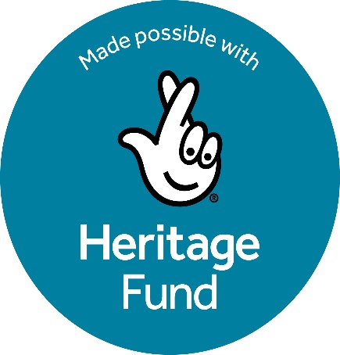
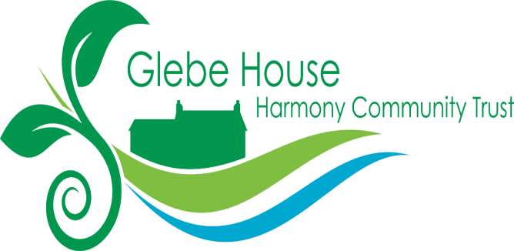

Project Information; The Glebe, a Green Community Hub for People and Pollinators
Our Glebe is located on the edge of Kilclief village within the Strangford & Lecale AONB and the Gullion, Mourne & Strangford
Our Glebe Estate contains an extraordinarily diverse range of habitats within its relatively small area of 8.5 acres. It is an ecological microcosm which includes a rare 1.5-acre wet woodland (a Priority Habitat), mature native trees including ash, sycamore and alder, young mixed woodland, an orchard, a wildlife pond, meadow and a willow garden (planted by many of those who participated in cross-community projects between 1975-2025). Its lack of managed cultivation has resulted in a host of diverse flora and fauna with the site offering a rare refuge in the intensively farmed Lecale Peninsula which surrounds it.
The Glebe’s Seedbed community garden (0.5 acres) is run by local volunteers along nature-friendly principles. Along with its herb garden participants grow an increasing array of fruit, vegetables, herbs and pollinators.
The site’s layered history includes its role as glebe land supporting the Church of Ireland clergy (from 1816) and a cross-community residential centre from 1975–2024. It is one of 67 Glebe townlands across Ireland with their own intangible heritage to explore as well as its place in the long ecclesiastical heritage of the Lecale.
There is a rich oral heritage of stories shared over the generations as well as the stories from the Glebe's cross-community years but which are not currently documented or accessible for all to share. Our current Glebe is a small fragment but one whose tangible environmental and intangible heritage is invaluable in so many ways. Each part is rich and diverse and when taken together can provide a whole array of opportunities to enrich the lives of not only our local community but that of the many visitors to this area of outstanding natural beauty

What we seek to achieve through this project
Through this project HCT aims to engage with its local communities in transforming its 8.5-acre Glebe House estate into a sustainable Green Community Hub, increasing environmental diversity and growing food in a nature-friendly way. Our vision is to achieve the conservation of our site’s fragile and ecologically rich environment, uncover and share its historical and cultural heritage, and build a long-term community-led model of stewardship and environmental education. By harnessing our rich social and environmental heritage resources through the process of creating a Land Use Map, Conservation Management Plan and associated Action Plan we aim to address social and environmental challenges including rural isolation and well-being. The legacy from this Phase 1 Project is to lay the foundations for future, larger-scale activities to develop HCT's vision of a welcoming space for all which aligns too with NLHF’s priorities of heritage conservation, environmental protection, community engagement, inclusion and organisational sustainability.
Project activities
Our project will have 8 distinct but interrelated Workstreams 1. Tangible and intangible heritage research of our site including a Baseline Preliminary Ecological Appraisal; undertaken in line with CIEEM standards and describing a complete habitat and biodiversity baseline for the entire site.

- Survey methods will allow for replicability to measure changes in future years and for specific species surveys as identified eg bats. We will also undertake intangible heritage research including oral history recordings and digital recording and presentation of other sources and documents to create a Glebe House Archive open to all.

- Community Engagement and Outreach; Survey 300 potential service users, hold 6 Open Meetings/consultation events with wider local community, consult with local schools and prepare a report on these activities – the Role Glebe House can play in our Community. We will also extend and deepen our engagement with four local primary schools with whom we already have planned a nest-box and pollinator planting initiative

- Learning Visits to other relevant sites in NI; 6 visits to sites of interest, 20 volunteers per visit. Prepare a Volunteers’ Report on Lessons for Glebe House from other Community Environmental ,Growing and Intangible Heritage Sites in NI.

- Consultations with professional (statutory and voluntary) Bodies and Agencies; Experienced volunteers will consult at least 10 relevant professional bodies/agencies and produce a Volunteers’ Report on views of selected professional bodies in relation to the future direction and potential of Glebe

- Develop nature-friendly horticultural, environmental and intangible heritage knowledge and skills of volunteers and service users; Deliver a Volunteer Training Programme 2025-26 around 10 different programmes for 40 volunteers in skills relevant to future of Glebe, including biodiversity surveying and management, willow management, nature-friendly horticultural practices, herbs and their uses, wildflower growing and seed collection and archival training and engagement initiatives

- Formal Participatory Planning Exercise and Articulation of future Management Plans; With a professional facilitator hold participatory meetings with a core group of 20-30 Volunteers,Trustees and a representative group of engaged Service Users identified through our community engagement, to achieve consensus and produce an approved set of Plans which take into account all issues identified in Activity Sets 1-5 above. This will include a Glebe Land Use Plan, a Conservation Management Plan (10 years 2026-2036) and a 3 Year Action Plan (2026-2029)

- Project Direction, Management and Communications Plan. This will include management of communications across all stakeholders, ensuring timely production of outputs, oversight of evaluation work and publicising outcomes through print, web, and social media. 8 Ongoing Evaluation of our Project: Using an experienced Volunteer to identify and evaluate all the key outcomes planned in relation to HLF's requirements/ Investment Principles for our project . All activities will be coordinated by a part-time Project Coordinator assisted by a professional Facilitator working closely with Trustees, volunteers, and partners.

