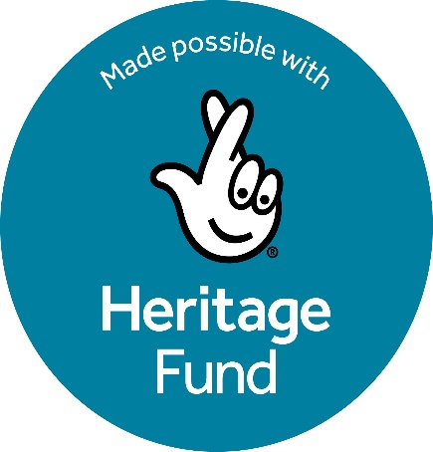
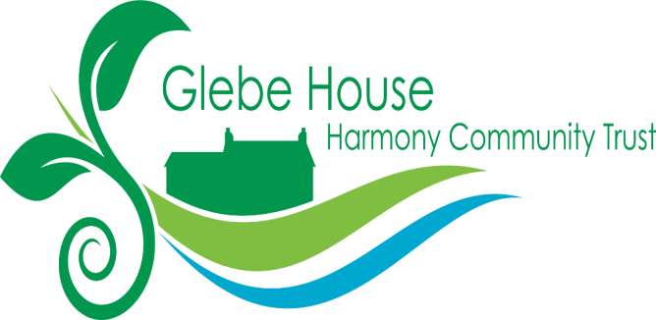

Invitation to Tender

Role: Ecology Consultant for the
Green Community Hub for People, Plants and Pollinators

Organisation: Harmony Community Trust (HCT)

Project title: The Green Community Hub for People, Plants and Pollinators

Role: Ecology Consultant

Location: Harmony Community Trust’s Glebe House estate, 23 Bishopscourt Road, Kilclief, BT30 7NZ

Duration of assignment: 12 months (months 4-15 of a 15-month project)

Funder: The National Lottery Heritage Fund

Reporting to: Green Community Hub Task Group (A sub group of four trustees who have responsibility for oversight of the project)

Budget; This is a fixed-price contract within the terms of the NLHF grant specification. The budget is £5,000 to include all time, expenses and VAT.

Closing date for tenders is 5pm Sunday 23rd November

Interviews for shortlisted consultants will be held on Monday 1st December

Offers are invited for the freelance position of Ecology Consultant. Candidates should provide a description of how they would approach the project, including evidence that they meet the personal specifications below, and an overall price, which should include all costs for personal time, expenses and VAT. Materials for use in presentations and report production will be provided by HCT.

Background Information
This project has been made possible through funding provided by the National Lottery Heritage Fund
In this project HCT aims to engage local communities and volunteers in transforming its 8.5-acre Glebe House estate into a sustainable Green Community Hub. Through this initiative we will conserve the site’s fragile and ecologically rich environment, uncover and share its historical and cultural heritage, and build a long-term community-led model of stewardship and environmental education which harnesses our rich social and environmental heritage.

The Ecology Consultant will work with the Green Community Hub Task Group at HCT to organise a programme of work for the project which embodies the project’s values and objectives and ensures that project outputs are achieved.
The strategic outcomes that this role will support are to:
- conserve our site’s fragile and ecologically rich environment,
- uncover and share its historical and cultural heritage, and
- build a long-term community-led model of stewardship and environmental education, harnessing our social and environmental heritage resources to address social and environmental challenges.
A copy of the full project description is attached.
Role of the Ecology Consultant
The role of the ecology Consultant will be to prepare;
- a Preliminary Ecological Appraisal (PEA) under CIEEM Guidelines and NIEA/DAERA Biodiversity Checklist and preliminary Ecological Assessment Reporting Format; this to also include a Soil Analysis Survey of different areas as agreed; the outcome to include mapping of survey results for the future environmental management of the site;

- a timetable to be drawn up and agreed with the Green Community Hub Task Group at HCT to maximise information collected of the whole Glebe House site (see map) during 2025-26 including checking the site and 25m buffer for invasive species. We envisage a number of surveys to reflect the seasons during 2025-26 which can provide the essential ecological baseline information required at the right time to help inform the processes and outcomes of the wider project;

- following the PEA and in agreement with the Green Community Hub Task Group at HCT, extended notes on other species of specific potential interest including birds, invertebrates, mammals, smooth newts and protected habitats where identified. The site has a Bat Colony resident in at least one of its buildings;

- a review of the nature conservation designations statutory or non-statutory for the site and relevant local area;

- guidance on mitigation, greening and biodiversity enhancement and management in consultation with the Volunteer Team and Green Community Hub Task Group at HCT for input to the site’s overall Conservation Management Plan and three-year Action Plan;

- workshop(s) on the potential development of Volunteer Citizen Science training to continue the ongoing monitoring and survey work required after the Stage 1 Project is completed.
Timeframe
The whole Heritage Fund Project is to be completed by 31st December 2026. The Ecology Survey is a key part of the baseline information necessary for the development of the Conservation and Action Plans and needs to be completed at the best time(s) and in tandem with the wider consultations ongoing as agreed with the Project Co-ordinator.
Time Commitment

The Ecology Consultant will estimate the time required to carry out the task and price their offer accordingly.
Reporting and Accountability

The Ecology Consultant will report to a nominated member of HCT Council of Management, who will also be a member of the Green Community Hub Task Group. They will work in cooperation with the Facilitator Planner and the Project Co-Ordinator.

Necessary conditions for this role

The successful candidate must be entitled to reside and work in the UK.

Personal requirements and specifications

Essential Requirements

The successful candidate will;
- Share and promote the values, aims and objectives of Glebe House/HCT, working within the ethos of the Trust to conserve our ecological heritage, promote good relations, social development and volunteering.

- Provide evidence of suitable qualifications to undertake PEA and associated species and habitat studies and reporting.

- Provide examples of similar previous work and experience of working with community conservation projects including workshops/engagement with volunteers.

- Provide evidence of the ability to communicate effectively both verbally and in writing, varying the style of communication to meet the needs and preferences of a diverse range of stakeholders

- Evidence good organizational skills to meet the requirements of the project and to consult appropriately with the Project Co-ordinator and the Green Community Hub Task Group to make required schedule changes

- Can evidence the ability to manage a budget and develop strategies for managing expenditure to align with budget

(Knowledge of Heritage Fund frameworks and requirement would be an advantage)

